Step 1: Open a terminal and type the following command:
$ dmesg | grep tty # This will give USB port in which GPS is connected
$ lsusb
Look for a line that mentions something like "Silicon Labs CP210x USB to UART Bridge".
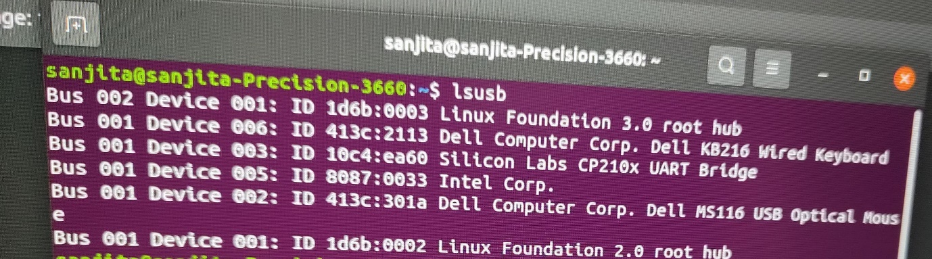
Step2: sudo cat /dev/ttyUSB0 > gps_output1.txt
(Please note USB can be USB0, USB1 etc. depend on which port gps module is connected)
This will save the output like
$GPGSA,A,1,,,,,,,,,,,,,,,*1E
$GLGSA,A,1,,,,,,,,,,,,,,,*02
$GNRMC,073936.089,V,,,,,0.53,162.90,041024,,,N*53
$GNVTG,162.90,T,,M,0.53,N,0.97,K,N*28
$GPGSA,A,1,,,,,,,,,,,,,,,*1E
$GLGSA,A,1,,,,,,,,,,,,,,,*02
$GNRMC,073936.089,V,,,,,0.53,162.90,041024,,,N*53
$GNVTG,162.90,T,,M,0.53,N,0.97,K,N*28
$GPGSA,A,1,,,,,,,,,,,,,,,*1E
If you want only GPGSA (which is required in our case filter out other, in that case step 2 is not required)
Step 3: cat /dev/ttyUSB1 | grep '\$GPGSA' > gpgsa_output.txt
If this is not work then
$ sudo cat /dev/ttyUSB1 | grep '\$GPGSA' > gpgsa_output.txt
$ sudo cat /dev/ttyUSB0 | grep '\$GNRMC’ > gnrmc_output.txt

sanjita@sanjita-Precision-3660:~$ cat /dev/ttyUSB0 | grep '\$GNRMC' > gnrmc_output111024.txt

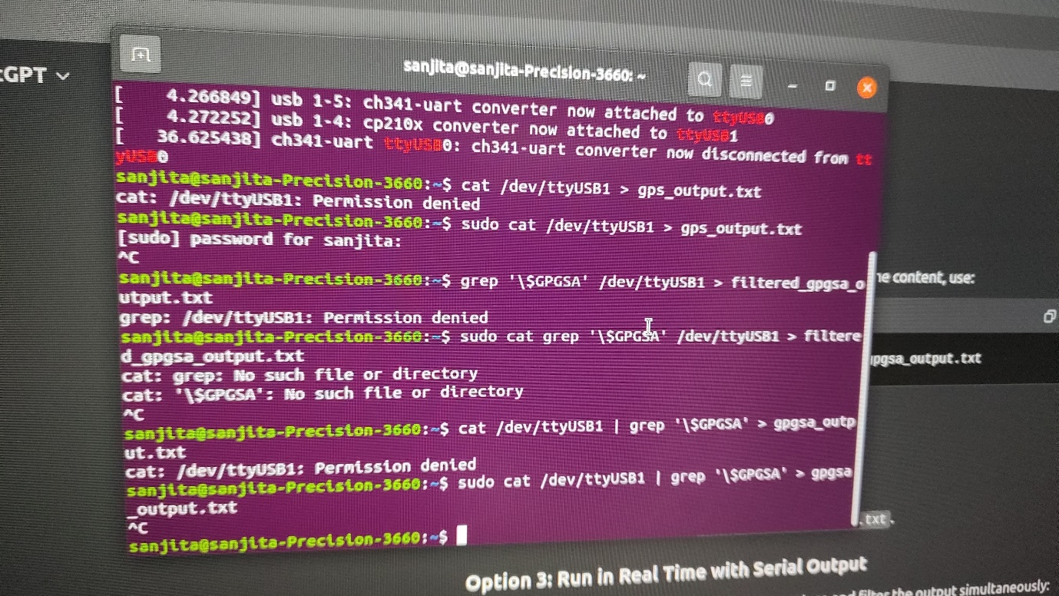
$GPGSA,A,1,,,,,,,,,,,,,,,*1E
$GPGSA,A,1,,,,,,,,,,,,,,,*1E
$GPGSA,A,1,,,,,,,,,,,,,,,*1E
$GPGSA,A,1,,,,,,,,,,,,,,,*1E
$GPGSA,A,1,,,,,,,,,,,,,,,*1E
$GPGSA,A,1,,,,,,,,,,,,,,,*1E
$GPGSA,A,1,,,,,,,,,,,,,,,*1E
$GPGSA,A,1,,,,,,,,,,,,,,,*1E
Step 4: to stop the recording
Type command
Press ctrl + C button

How to run GPS

Step 1 Start GPS
Go to directory where file start_gps.sh is present in our case
sanjita@sanjita-Precision-3660:~/GPS$ ./start_gps.sh
Step 2 Stop GPS recording
click on + button and open new terminal on the terminal where gps is running.
Run: ps aux | grep gps_script.py
sanjita@sanjita-Precision-3660:~/GPS$ ps aux | grep gps_script.py
this will give following output
sanjita 4652 96.0 0.0 18908 10212 pts/2 R+ 18:54 6:06 python3 /home/sanjita/GPS/gps_script.py
sanjita 4842 0.0 0.0 9044 712 pts/3 S+ 19:01 0:00 grep --color=auto gps_script.py
Now type
kill <PID>
kill 4652 (Please note this 4652 will change every time so we have keep the PID which is coming first line of running ps aux | grep gps_script.py in this case 4652)
sanjita@sanjita-Precision-3660:~/GPS$ kill 4652
(Please note 4652 is not fixed)

This will terminate the GPS recording

